SETUP INSTRUCTIONS FOR A VIDEO CONSULTATION WITH MYTHULU

Thank you for scheduling a consultation! This guide will prepare you for a video broadcast with Mythulu.

CONNECTION METHOD:

PUBLIC CONSULTATIONS: Mythulu will initiate a video call with you over Discord. Mythulu will then broadcast the call (both audio and visual) over Twitch. A link is provided that you can share with your friends.
PRIVATE CONSULATIONS: Mythulu will still initiate a video call over Discord. We will record the consultation privately for your records, but it will not be streamed.

SETUP INSTRUCTIONS:
STEP ONE: Download Discord to your computer. Discord is free to download and install here. Please register an account and log in.
After you’ve installed Discord and login to your account, you should have this interface:
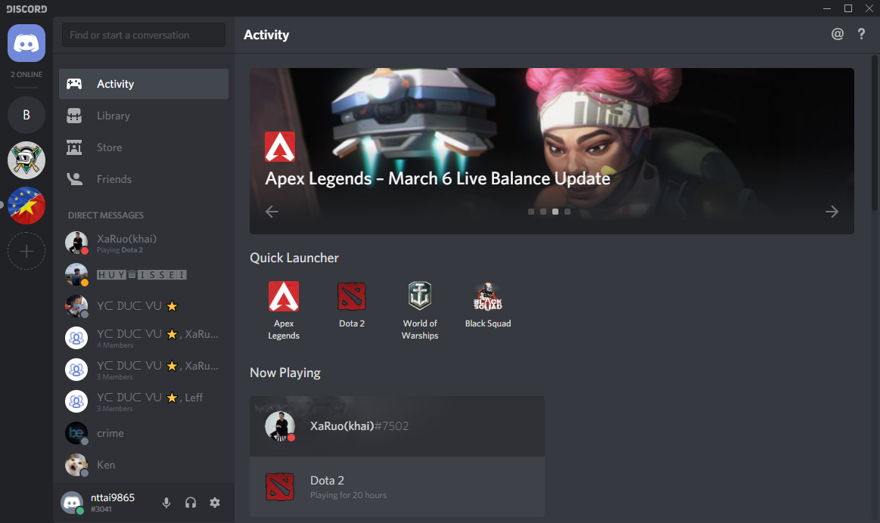

STEP TWO: Send a friend request to Mhafweet#0440. To send a friend request in Discord, you just need to point your mouse over this textbox here:
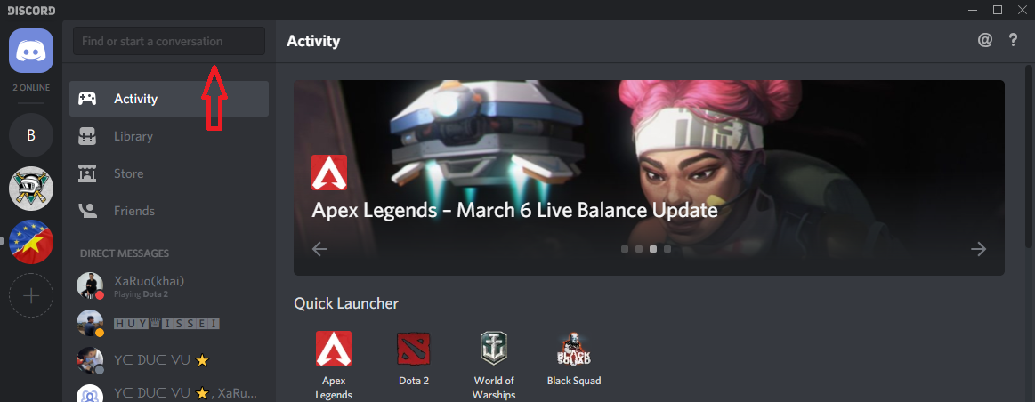
Type the username like this:
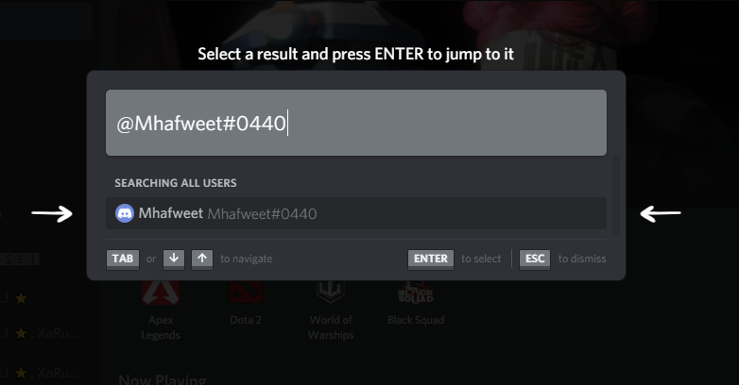
(If you have trouble pulling up the right name, try adding a space and typing “Mhafweet #0440”)

Click the name that appeared and send a friend request to the account. After that, inform Laura about the friend request to get accepted. Please include your username.

SOME REQUIREMENTS BEFORE THE LIVE-STREAM STARTS
In order to make our stream professional and smooth, please:
- Sit in a quiet room
- Put your phone in Do Not Disturb or Airplane mode
- Test your microphone to make sure it works and isn’t picking up weird sounds.
- Wear earbuds/earphones to prevent echo
!!!IMPORTANT!!!
- You MUST log in 30 minutes before the live-stream starts. Before initiating live-stream, we troubleshoot technical details, do a short test recording, and answer any questions you have about the stream.
- We stream every Wednesday at 6PM Arizona time. Please be online by 5:30.
- For private appointments, please log on 10 minutes prior.

TO WATCH / SHARE WITH FRIENDS
Live streams will be broadcast on this Twitch channel: https://www.twitch.tv/mhafweet.
Please let your friends know you’ll be streaming with us!

